ASSIGNMENT 8
1. Write program using functions for binary tree traversals: Pre-order, In-order and Post. order using a recursive approach.

#include <iostream>
using namespace std;

struct Node {
int data;
Node* left;
Node* right;

Node(int val) {
data = val;
left = right = NULL;
}
};

void printTree(Node* root, int space = 0) {
if (root == NULL) return;

space += 6;

printTree(root->right, space);

cout << endl;
for (int i = 6; i < space; i++)
cout << " ";
cout << root->data;

printTree(root->left, space);
}

void preorder(Node* root) {
if (root == NULL) return;
cout << root->data << " ";
preorder(root->left);
preorder(root->right);
}

void inorder(Node* root) {
if (root == NULL) return;
inorder(root->left);
cout << root->data << " ";
inorder(root->right);
}

void postorder(Node* root) {
if (root == NULL) return;
postorder(root->left);
postorder(root->right);
cout << root->data << " ";
}

int main() {
// Creating the standard binary tree
Node* root = new Node(1);
root->left = new Node(2);
root->right = new Node(3);
root->left->left = new Node(4);
root->left->right = new Node(5);
root->right->left = new Node(6);
root->right->right = new Node(7);

cout << "Binary Tree Structure:\n";
printTree(root);

cout << "\n\nPre-order Traversal : ";
preorder(root);

cout << "\nIn-order Traversal : ";
inorder(root);

cout << "\nPost-order Traversal : ";
postorder(root);

cout << endl;
return 0;
}

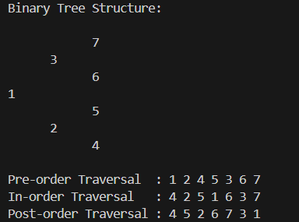

2. Implement following functions for Binary Search Trees
(a) Search a given item (Recursive & Non-Recursive)
(b) Maximum element of the BST
(c) Minimum element of the BST
(d) In-order successor of a given node the BST
(e) In-order predecessor of a given node the BST

#include <iostream>
using namespace std;

struct Node {
int data;
Node* left;
Node* right;

Node(int val) {
data = val;
left = right = NULL;
}
};

Node* insertNode(Node* root, int val) {
if (root == NULL)
return new Node(val);

if (val < root->data)
root->left = insertNode(root->left, val);
else
root->right = insertNode(root->right, val);

return root;
}

// (a) Recursive Search
Node* searchRec(Node* root, int key) {
if (root == NULL || root->data == key)
return root;

if (key < root->data)
return searchRec(root->left, key);
return searchRec(root->right, key);
}

// (a) Non-recursive Search
Node* searchIter(Node* root, int key) {
while (root != NULL) {
if (root->data == key)
return root;
else if (key < root->data)
root = root->left;
else
root = root->right;
}
return NULL;
}

// (b) Maximum element in BST
Node* findMax(Node* root) {
if (root == NULL) return NULL;

while (root->right != NULL)
root = root->right;

return root;
}

// (c) Minimum element in BST
Node* findMin(Node* root) {
if (root == NULL) return NULL;

while (root->left != NULL)
root = root->left;

return root;
}

// (d) In-order Successor
Node* inorderSuccessor(Node* root, int key) {
Node* curr = searchIter(root, key);
if (curr == NULL) return NULL;

// Case 1: Right subtree exists → successor = min(right)
if (curr->right != NULL)
return findMin(curr->right);

// Case 2: No right subtree → find ancestor
Node* successor = NULL;
Node* ancestor = root;

while (ancestor != curr) {
if (curr->data < ancestor->data) {
successor = ancestor;
ancestor = ancestor->left;
} else {
ancestor = ancestor->right;
}
}
return successor;
}

// (e) In-order Predecessor
Node* inorderPredecessor(Node* root, int key) {
Node* curr = searchIter(root, key);
if (curr == NULL) return NULL;

// Case 1: Left subtree exists → predecessor = max(left)
if (curr->left != NULL)
return findMax(curr->left);

// Case 2: No left subtree → find ancestor
Node* predecessor = NULL;
Node* ancestor = root;

while (ancestor != curr) {
if (curr->data > ancestor->data) {
predecessor = ancestor;
ancestor = ancestor->right;
} else {
ancestor = ancestor->left;
}
}
return predecessor;
}

// In-order Print for reference
void inorder(Node* root) {
if (root == NULL) return;
inorder(root->left);
cout << root->data << " ";
inorder(root->right);
}

int main() {
Node* root = NULL;

// Constructing BST
int arr[] = {20, 10, 30, 5, 15, 25, 40};
for (int x : arr)
root = insertNode(root, x);

cout << "BST (In-order): ";
inorder(root);
cout << endl;

int key = 15;

// Search
cout << "\nSearching for " << key << " (Recursive): ";
cout << (searchRec(root, key) ? "Found" : "Not Found");

cout << "\nSearching for " << key << " (Iterative): ";
cout << (searchIter(root, key) ? "Found" : "Not Found");

// Min & Max
cout << "\n\nMinimum Element: " << findMin(root)->data;
cout << "\nMaximum Element: " << findMax(root)->data;

// Successor & Predecessor
Node* succ = inorderSuccessor(root, key);
Node* pred = inorderPredecessor(root, key);

cout << "\n\nIn-order Successor of " << key << ": ";
if (succ) cout << succ->data; else cout << "None";

cout << "\nIn-order Predecessor of " << key << ": ";
if (pred) cout << pred->data; else cout << "None";

cout << endl;
return 0;
}

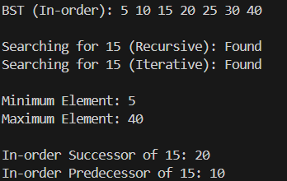
3. Write a program for binary search tree (BST) having functions for the following
operations:
(a) Insert an element (no duplicates are allowed),
(b) Delete an existing element,
(c) Maximum depth of BST
(d) Minimum depth of

#include <iostream>
using namespace std;

struct Node {
int data;
Node* left;
Node* right;

Node(int val) {
data = val;
left = right = NULL;
}
};

Node* insertNode(Node* root, int val) {
if (root == NULL)
return new Node(val);

if (val < root->data)
root->left = insertNode(root->left, val);
else if (val > root->data)
root->right = insertNode(root->right, val);
else
cout << "Duplicate value, not inserted.\n";

return root;
}

Node* findMin(Node* root) {
while (root->left != NULL)
root = root->left;
return root;
}

Node* deleteNode(Node* root, int key) {
if (root == NULL)
return NULL;

if (key < root->data)
root->left = deleteNode(root->left, key);
else if (key > root->data)
root->right = deleteNode(root->right, key);
else {
if (root->left == NULL && root->right == NULL) {
delete root;
return NULL;
}
else if (root->left == NULL) {
Node* t = root->right;
delete root;
return t;
}
else if (root->right == NULL) {
Node* t = root->left;
delete root;
return t;
}
else {
Node* t = findMin(root->right);
root->data = t->data;
root->right = deleteNode(root->right, t->data);
}
}
return root;
}

int maxDepth(Node* root) {
if (root == NULL) return 0;
return 1 + max(maxDepth(root->left), maxDepth(root->right));
}

int minDepth(Node* root) {
if (root == NULL) return 0;
if (root->left == NULL)
return 1 + minDepth(root->right);
if (root->right == NULL)
return 1 + minDepth(root->left);
return 1 + min(minDepth(root->left), minDepth(root->right));
}

void inorder(Node* root) {
if (root == NULL) return;
inorder(root->left);
cout << root->data << " ";
inorder(root->right);
}

int main() {
Node* root = NULL;
int choice, val;

while (true) {
cout << "\n--- BST MENU ---\n";
cout << "1. Insert Node\n";
cout << "2. Delete Node\n";
cout << "3. Display Inorder\n";
cout << "4. Maximum Depth\n";
cout << "5. Minimum Depth\n";
cout << "6. Exit\n";
cout << "Enter choice: ";
cin >> choice;

switch (choice) {
case 1:
cout << "Enter value to insert: ";
cin >> val;
root = insertNode(root, val);
break;

case 2:
cout << "Enter value to delete: ";
cin >> val;
root = deleteNode(root, val);
break;

case 3:
cout << "Inorder Traversal: ";
inorder(root);
cout << endl;
break;

case 4:
cout << "Maximum Depth: " << maxDepth(root) << endl;
break;

case 5:
cout << "Minimum Depth: " << minDepth(root) << endl;
break;

case 6:
return 0;

default:
cout << "Invalid choice!\n";
}
}

return 0;
}
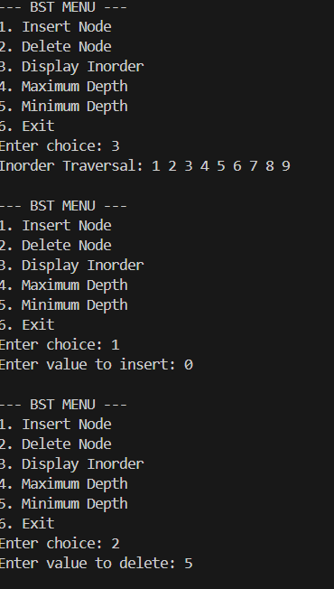

4. Write a program to determine whether a given binary tree is a BST or not.

#include <iostream>
#include <climits>
using namespace std;

struct Node {
int data;
Node* left;
Node* right;

Node(int val) {
data = val;
left = right = NULL;
}
};

// Function to check BST property using min/max range
bool isBSTUtil(Node* root, int minVal, int maxVal) {
if (root == NULL)
return true;

if (root->data <= minVal || root->data >= maxVal)
return false;

return isBSTUtil(root->left, minVal, root->data) &&
isBSTUtil(root->right, root->data, maxVal);
}

bool isBST(Node* root) {
return isBSTUtil(root, INT_MIN, INT_MAX);
}

// Inorder print for verifying tree contents
void inorder(Node* root) {
if (root == NULL) return;
inorder(root->left);
cout << root->data << " ";
inorder(root->right);
}

int main() {

/*
Creating a general binary tree
8
/ \
3 10
/ \ \
12 6 14

This is **NOT** a BST (12 is in the left subtree of 8)
*/

Node* root = new Node(8);
root->left = new Node(3);
root->right = new Node(10);
root->left->left = new Node(12); // breaks BST rule
root->left->right = new Node(6);
root->right->right = new Node(14);

cout << "Inorder Traversal of the Tree: ";
inorder(root);
cout << endl;

if (isBST(root))
cout << "The tree IS a BST.\n";
else
cout << "The tree is NOT a BST.\n";

return 0;
}

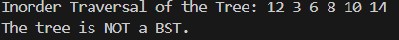
5. Implement Heapsort (Increasing/Decreasing order).

#include <iostream>
#include <vector>
using namespace std;

void heapify(vector<int>& arr, int n, int i) {
int largest = i;
int left = 2*i + 1;
int right = 2*i + 2;

if (left < n && arr[left] > arr[largest])
largest = left;

if (right < n && arr[right] > arr[largest])
largest = right;

if (largest != i) {
swap(arr[i], arr[largest]);
heapify(arr, n, largest);
}
}

void heapSortIncreasing(vector<int>& arr) {
int n = arr.size();

for (int i = n/2 - 1; i >= 0; i--)
heapify(arr, n, i);

for (int i = n - 1; i >= 0; i--) {
swap(arr[0], arr[i]);
heapify(arr, i, 0);
}
}

// For decreasing: build MIN-heap
void heapifyMin(vector<int>& arr, int n, int i) {
int smallest = i;
int left = 2*i + 1;
int right = 2*i + 2;

if (left < n && arr[left] < arr[smallest])
smallest = left;

if (right < n && arr[right] < arr[smallest])
smallest = right;

if (smallest != i) {
swap(arr[i], arr[smallest]);
heapifyMin(arr, n, smallest);
}
}

void heapSortDecreasing(vector<int>& arr) {
int n = arr.size();

for (int i = n/2 - 1; i >= 0; i--)
heapifyMin(arr, n, i);

for (int i = n - 1; i >= 0; i--) {
swap(arr[0], arr[i]);
heapifyMin(arr, i, 0);
}
}

int main() {
int n;
cout << "Enter number of elements: ";
cin >> n;

vector<int> arr(n);
cout << "Enter elements:\n";
for (int i = 0; i < n; i++)
cin >> arr[i];

int choice;
cout << "\n1. Sort Increasing\n2. Sort Decreasing\nEnter choice: ";
cin >> choice;

if (choice == 1)
heapSortIncreasing(arr);
else if (choice == 2)
heapSortDecreasing(arr);
else
cout << "Invalid choice!\n";

cout << "\nSorted Array: ";
for (int x : arr)
cout << x << " ";
cout << endl;

return 0;
}

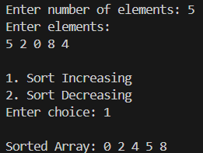

6. Implement priority queues using heaps.

#include <iostream>
#include <vector>
using namespace std;

class PriorityQueue {
public:
vector<int> heap;

// Function to swap two values
void swapVals(int &a, int &b) {
int temp = a;
a = b;
b = temp;
}

// Push an element (insert)
void push(int val) {
heap.push_back(val);
int i = heap.size() - 1;

// Up-heap bubbling
while (i > 0) {
int parent = (i - 1) / 2;
if (heap[parent] < heap[i]) {
swapVals(heap[parent], heap[i]);
i = parent;
} else break;
}
}

// Pop the highest priority element
void pop() {
if (heap.empty()) {
cout << "Priority Queue is empty.\n";
return;
}

// Move last element to root
heap[0] = heap.back();
heap.pop_back();

// Down-heap trickle
heapify(0);
}

// Heapify function (max-heap)
void heapify(int i) {
int size = heap.size();
int largest = i;
int left = 2*i + 1;
int right = 2*i + 2;

if (left < size && heap[left] > heap[largest])
largest = left;

if (right < size && heap[right] > heap[largest])
largest = right;

if (largest != i) {
swapVals(heap[i], heap[largest]);
heapify(largest);
}
}

// Return highest priority element
int top() {
if (heap.empty()) {
cout << "Priority Queue is empty.\n";
return -1;
}
return heap[0];
}

// Display the heap
void display() {
if (heap.empty()) {
cout << "Priority Queue is empty.\n";
return;
}
cout << "Priority Queue (Heap): ";
for (int x : heap)
cout << x << " ";
cout << endl;
}
};

int main() {
PriorityQueue pq;
int choice, val;

while (true) {
cout << "\n--- PRIORITY QUEUE MENU ---\n";
cout << "1. Insert (Push)\n";
cout << "2. Delete Highest Priority (Pop)\n";
cout << "3. Peek (Top Element)\n";
cout << "4. Display\n";
cout << "5. Exit\n";
cout << "Enter choice: ";
cin >> choice;

switch (choice) {
case 1:
cout << "Enter value to insert: ";
cin >> val;
pq.push(val);
break;

case 2:
pq.pop();
break;

case 3:
cout << "Top element: " << pq.top() << endl;
break;

case 4:
pq.display();
break;

case 5:
return 0;

default:
cout << "Invalid choice!\n";
}
}
}

